COFFEE BREAK WITH ACE!(get it because java!?)

JAVA CHEAT

Quick introduction to data types.

|  |  |
| --- | --- |
| **Type** | **Explanation** |
| int | A 32-bit (4-byte) integer value |
| short | A 16-bit (2-byte) integer value |
| long | A 64-bit (8-byte) integer value |
| byte | An 8-bit (1-byte) integer value |
| float | A 32-bit (4-byte) floating-point value |
| double | A 64-bit (8-byte) floating-point value |
| char | A 16-bit character using the Unicode encoding scheme |
| boolean | A true or false value |

I basically had them try to break down what we would need to declare variable wise to make a card and then talked about what if we wanted a card object to make an entire deck.

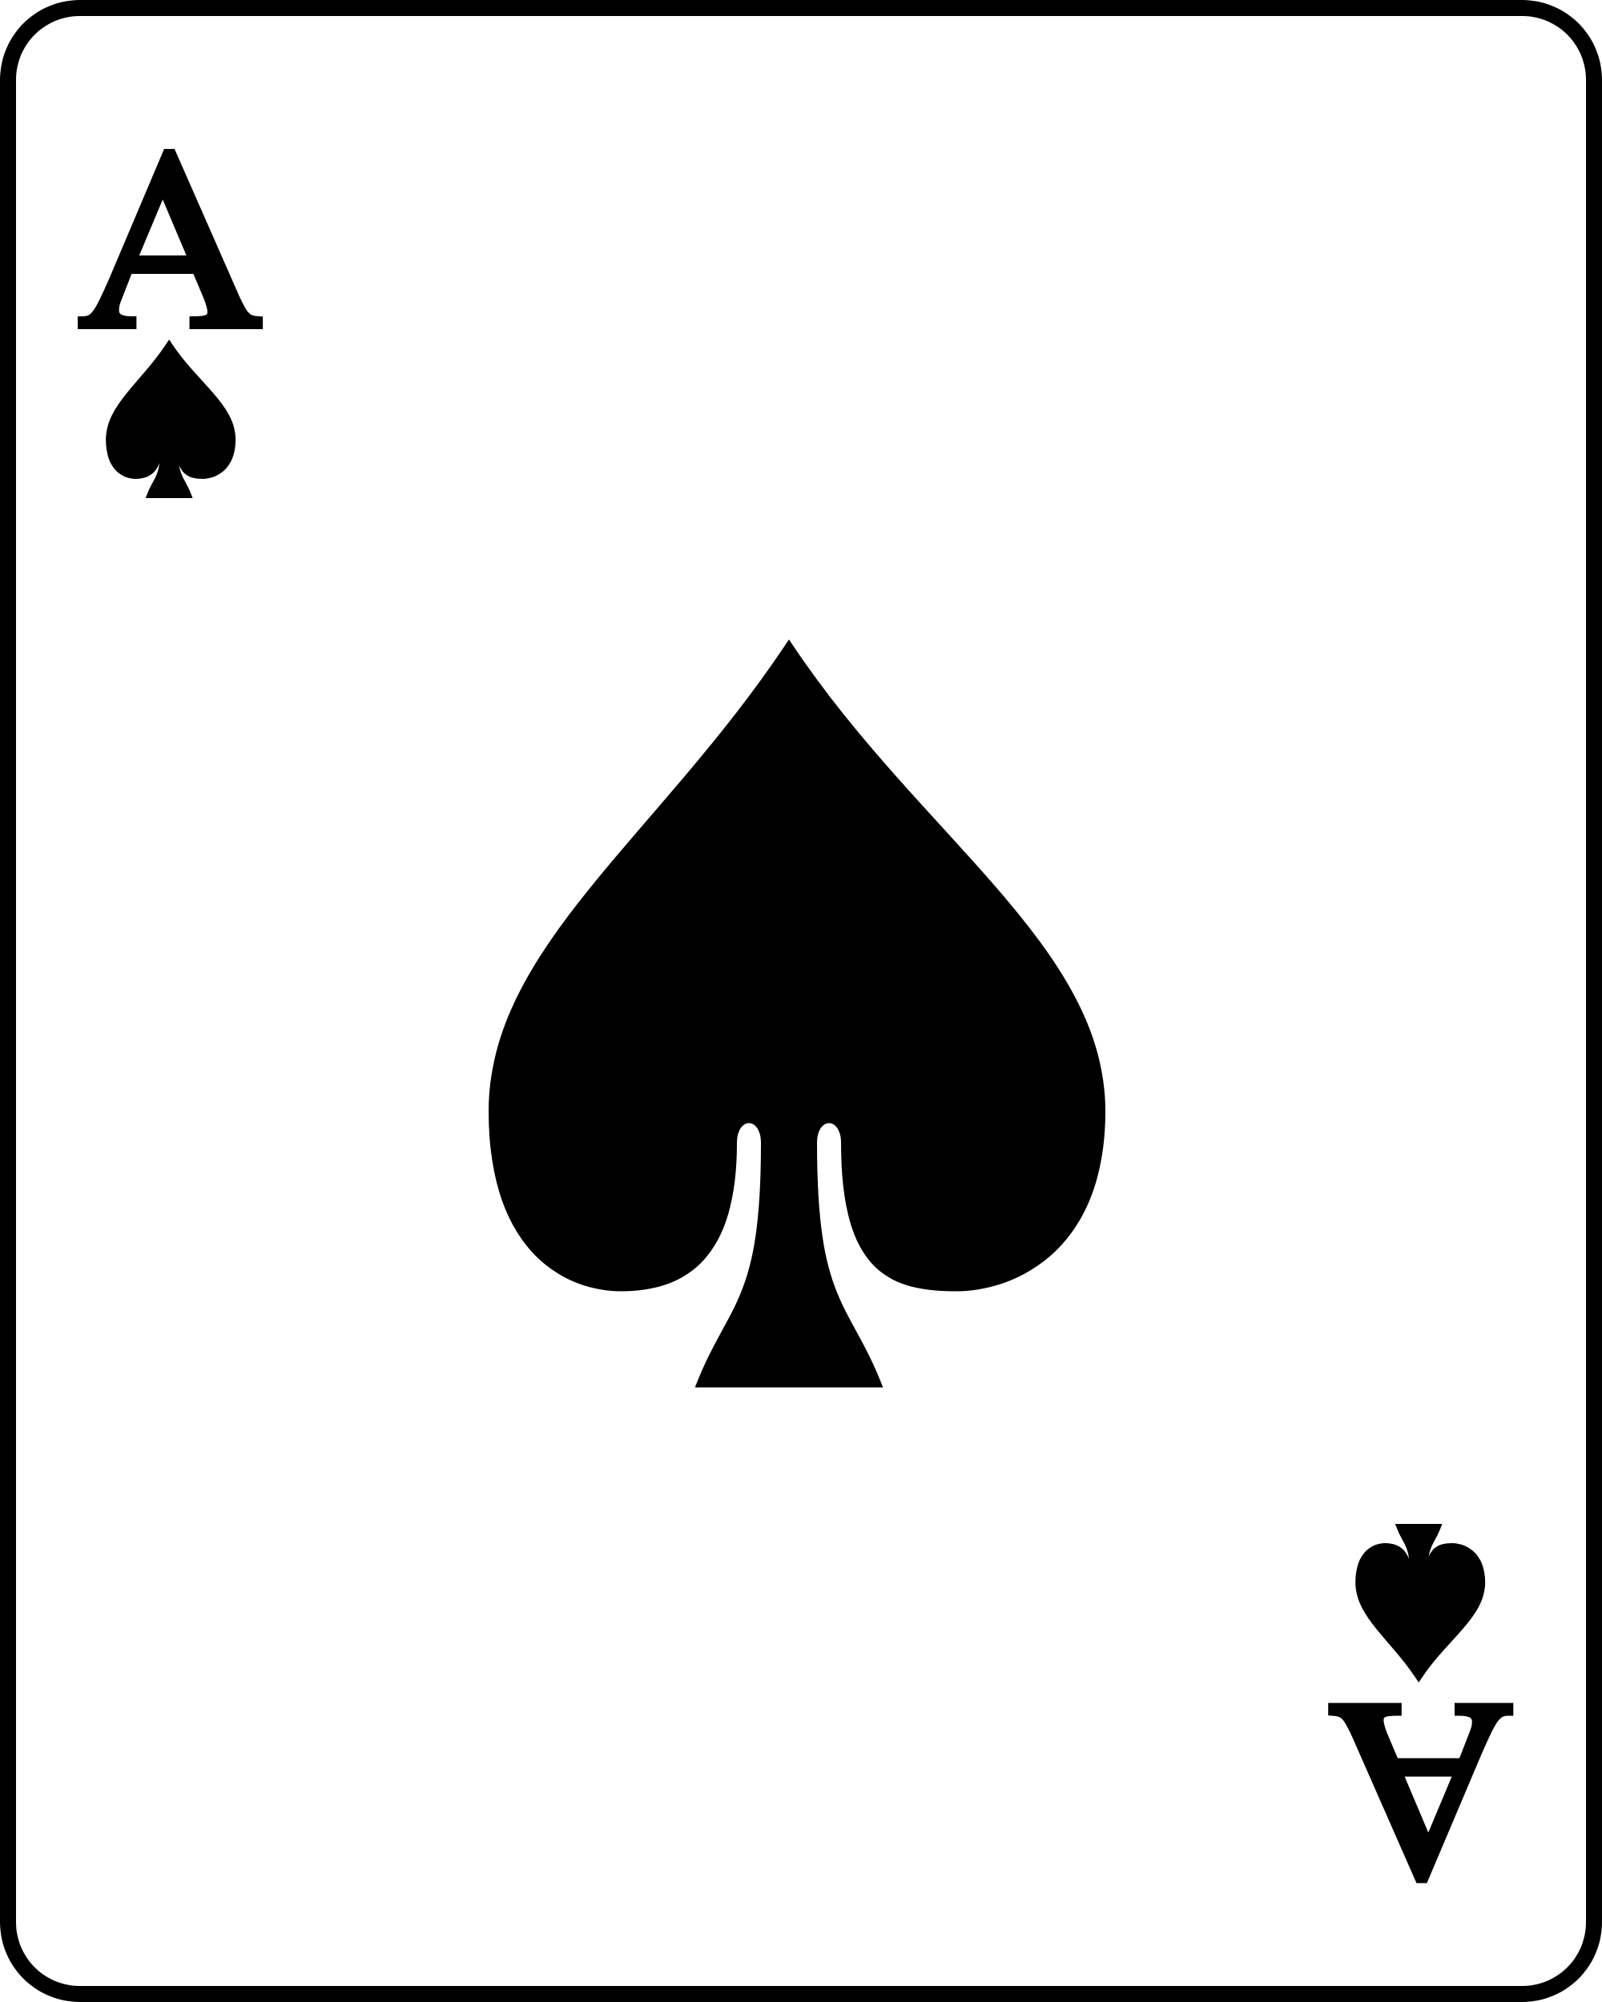

Above is a card! ...duh ACE I know it is card, but why did you put a random ACE on the worksheet? Well youngling it is because we are going to use it to talk about OBJECTS! What is an object? Well if we have a deck of cards we do not want to make 4000 cards we want to be able to make one or program our program to make cards for us. What would our object require?

Look at the card and below write what you think we would need to get and set from our card to make a deck of them. Something we might need to get would be the color of the card. Something we might need to set is the color as well. If we make a card we need to be able to decided the color and also know what color the card is.

Some basic programming stuff for them.

What is a getter?

What is a setter?

What do we end each line of code with?

Below is a bunch of code declaring variables! Pay close attention and soon you will be able to do this yourself!

int a, b, c; // Declares three ints, a, b, and c.  
int a = 10, b = 10; // Example of initialization  
byte B = 22; // initializes a byte type variable B.  
double pi = 3.14159; // declares and assigns a value of PI.  
char a = 'a'; // the char variable a iis initialized with value 'a'

My purpose here was to get them coding or at least pseudo coding. They have a ton to learn day 1 and its really great to let them interact with the kid without the computer.

Make me a variable of string type named george with the value “Bacon”.

Make me a variable of Int type named Age that is equal to 12!

Now add 5 to the variable Age and store it in Age!

Now store the value 2.34243 in the variable named cheese!

// Copy this code box into your class file

I went line by line with them and read the code so when they copied it they would understand what it did. If you want you can make a fill in the blank for them or have them hand write in the code from the module so they can copy this sheet to have their first program.

/*

* Minecraft Text Adventure

*

*/

import java.util.Scanner;

public class MineExplorer {

// Variables created here can be used anywhere in this class file. They will be set to these values when the program starts.

// Variable to keep track of the player's health while the program is running

static int playerHealth = 100;

// Keep track of ore that the player found

static int ore = 0;

static String playerName = "Steve";

// Create a scanner to get what the user types

static Scanner input = new Scanner(System.in);

static String playerInput;

// Store a true of false value to check if the player ran away from the mine

static boolean runAway = false;

public static void main(String[] args) {

// When the program runs, it will start here

// Run until player dies or runs away.

while(playerHealth > 0 && !runAway){

// Find some ore in the mines.

int oreFound = 5;

System.out.println(playerName +" found " + oreFound + " ore.");

ore += oreFound; // Give the player ore found

System.out.println(playerName +" has " + ore + " total ore.");

// Ask if the player wants to keep searching for ore.

System.out.println("Keep searching for ore? (yes, no)");

playerInput = input.nextLine();

playerInput = playerInput.toLowerCase();

// if the player says anything other than yes, stop.

if(!playerInput.contains("yes")){

runAway = true;

break;

}

}

System.out.println(playerName + " runs out of the mine.");

System.out.println(playerName + " made it out of the mine with " + ore + " ore.");

}

}